**How to create a CrypCloud account**

First, click on the CrypCloud icon (“Connect”) in the CT2 ribbon bar:

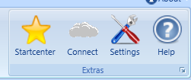

After that, click in the CrypCloud login Screen on “Create new account”:

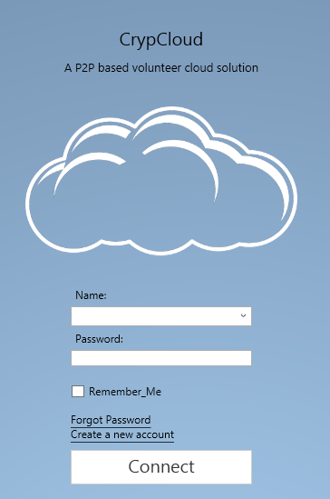

Enter your new account credentials: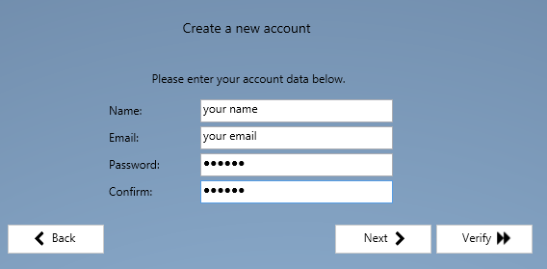

You need a valid email address. Your password will be used to encrypt your CT2 user certificate. For convenience reasons the certificate is stored ENCRYPTED at the CT2 certification authority server. You can use your login data from ANY computer that has access to the CrypTool Cloud since the certificate will be automatically downloaded at a login-attempt. Therefore, we recommend to use a password manager, i.e. Keepass2 (<http://keepass.info/download.html>), and generate a strong random generated password with at least 16byte length to protect your account.

After entering your credentials click the “Next” Button.

You will receive a confirmation email which contains a verification code.

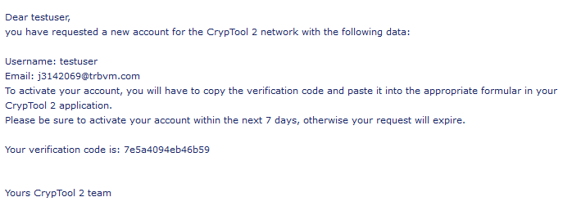

Copy that code in the verification field:

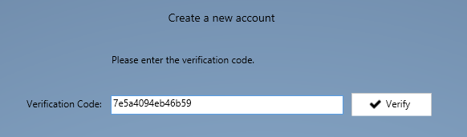

Press the “Verify” button.

You should finally see that your “Account was successfully requested”.

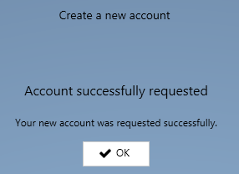

From now on, you can use your account to log into the CrypCloud.